SUBSIDIZED PROGRAM
ON FOOD SECURITY

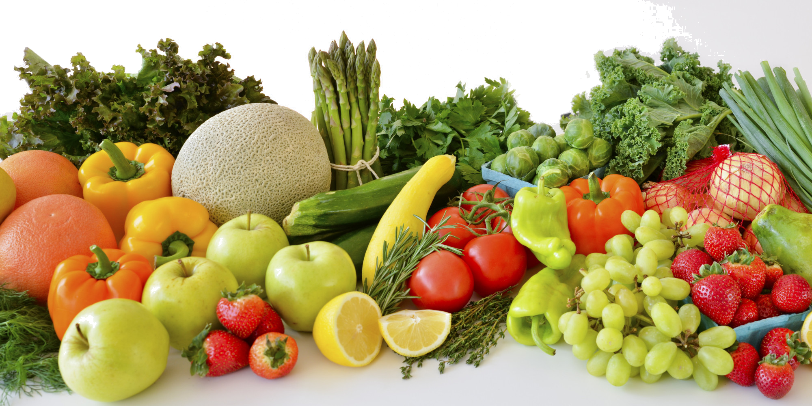
Name of project :
Name of promoter :
Name of partners :

All requests for the SUBSIDIZED PROGRAM ON FOOD SECURITY for the year 2018–2019 must be received before January 18th at 5 p.m. They must be sent to :

Mrs. Lise D’Astous
Direction de santé publique
Centre intégré de santé et de services sociaux de la Côte-Nord
835, boul. Jolliet, Baie-Comeau (Québec) G5C 1P5
Téléphone : 418 589-9845, poste 252287
Télécopieur : 418 589-8574
Courriel : lise.dastous.09cisss@ssss.gouv.qc.ca

Prior to filling out the Project Presentation Form, please read the Regional Management Guide for the Food Security Subsidy Program, which defines promoters, types of admissible projects, selection process as well as some other pertinent information. The Guide was written in order to help you fill out your request.

1. Information on the institution or group promoting the project:

Name of promoter :
Address :
Postal address :
(if different than above)
Person in charge :
Telephone number :
Fax number :
E-mail :

2. PRESENTATION OF THE CONSULTATION PROCESS

A. Explanation of the consultation mechanism

- Is the project part of an existing consultation?
If so, which one? Describe its mandate and the link with food security.
If not, present the mobilization and consultation process which led to the presentation of the project.
B. Description of the partners’ involvement in the development and the carrying out of the project
- Who are the partners?
- Frequency of meetings?
- What is the role of the partners involved in the carrying out of the project (who does what)?

3. PRESENTATION OF THE PROJECT TO SUBSIDIZE

- Needs of the community (which situation do you want to remedy?)
- Short description of the problem

- Target group :
Low income
Low educational level
Single parenting
Belonging to a large household
Others
Objectives :
- Which elements will allow favouring better food security for the target group?
- Description of the project
- The project acts on which determinant of food security?
Interpersonal and social environment: family and food culture
Physical environment: availability and access to foods
Economic environment: purchasing power and cost of food
Public policies: related to income, accommodation, agriculture, transportation
Explain :
- What are the elements that will ensure the sustainability of the project?

C. OPERATIONAL DESCRIPTION OF THE PROJECT
Operational objectives  (Who does What,  for Whom and Where) | Planned activities  (Name the activities, interventions  or duties to be accomplished for the project) | Responsible  Group/Person | Deadlines  (Start-up and completion dates)

4. Briefly describe the activities planned which will help attain expected results (ex. : logbook, participation ratio, observations, results diffusion …) :

5. Budget estimates (fill in the form) :
Please refer to the Guide de gestion regional of the Programme de subvention en sécurité alimentaire in order to check the admissibility of expenses.
Income (A) |  | $
- Partners contribution :
- Participants contribution :
- Others (please give details, ex.: sponsors contribution, subsidy, etc.) :
 | -
 | -
 | -
TOTAL INCOME
Expenses (A) |  | $
- Salaries
Hourly rate : Hours :
- Social benefits, employer’s share
% :
- Travelling expenses
- Office supplies
- Food supply (maximum of 25 %)
- Material (please give details) :
 | -
 | -
 | -
- Other expenses (please give details) :
 | -
 | -
 | -
TOTAL EXPENSES
Amount required |  | $
Income (A)
Expenses (B) -
TOTAL REQUIRED : =

